Resistance Spot Welding of Automotive Grade Steels.

Piu Chatterjee, Suraj Mahato*, Shaquib Ali*, Dr. Tapas Kumar Roy, Dr. Tushar Banerjee, and Dr. Kanwer Singh Arora*
Production and Industrial Engineering, National Institute of Technology Jamshedpur.
*Research and Development, Tata Steel Limited, Jamshedpur
*Email: cpihu3289@gmail.com; Phone: 9717175613

Abstract
Resistance Spot Welding (RSW) is one of the most widely used joining processes in the automotive industry for assembling sheet metal components. In the present study, dissimilar welding of DP1180 advanced high-strength steel (1.2 mm) and Interstitial Free (IF) steel (0.8 mm) was investigated using a Medium Frequency Direct Current (MFDC) resistance spot welding machine. The objective of the work was to determine suitable welding parameters, evaluate weld quality, and study the microstructural characteristics of the welded joints.
Initially, welding trials were conducted by varying the welding current from 5 kA to 8 kA while maintaining constant welding time and electrode force. The occurrence of expulsion was monitored to identify the upper limit of the welding current. Expulsion was observed at 7.5 kA, and therefore 6.5 kA was selected as the optimum welding current for further experimentation. Welded samples were produced in two configurations: DP1180 on top with IF steel at the bottom, and IF steel on top with DP1180 at the bottom.
The welded specimens were subjected to tensile testing to evaluate joint strength, and the weld nugget diameters and depth of penetration were measured using a Stereo Microscope. Metallographic sample preparation involving sectioning, hot mounting using Bakelite, polishing, and etching was performed on selected samples for microstructural examination. The results demonstrated successful formation of sound weld joints at the selected welding parameters, providing valuable insight into the welding behaviour of DP1180–IF steel dissimilar combinations.
Keywords: Resistance Spot Welding (RSW), DP1180 Steel, Interstitial Free (IF) Steel, Dissimilar Welding
Chapter 1 Introduction to Resistance Spot Welding 1
1.1 History Of Resistance Spot Welding: 1
1.2 Resistance Spot Welding: 1
1.3 Joule Heating: 2
1.4 Process Involved in Resistance Spot Welding: 2
1.5 Resistance Spot Welding Cycle 3
1.6 Resistance Spot Welding in Automotive Industry 5
1.7 Dissimilar Resistance Spot Welding 7
1.8 VARIOUS RESEARCH APPROACHES TO ENHANCE THE PERFORMANCE OF DISSIMILAR METAL WELDS 8
Chapter 2 Material Selection 12
2.1 Introduction 12
2.2 Advanced High Strength Steel 13
2.3 Selection of DP1180 Steel 14
2.4 Selection of IF Steel 16
2.5 Justification for the Selection of Materials (DP1180 and IF Steel) 17
2.6 Conclusion 18
Chapter 3 Parameter Selection for Weld Condition 19
3.1 Introduction 19
3.2 Material Considerations 19
3.3 Selection of Welding Current 19
3.4 Selection of Weld Time 20
3.5 Selection of Electrode Force 20
3.6 Selection of Squeeze Time 20
3.7 Selection of Hold Time 21
3.8 Electrode Selection 21
3.9 Final Welding Schedule 21
3.10 Summary 21
Chapter 4 Welding Experiment 22
4.1 Objective of the Experiment 22
4.2 Experimental Procedure 22
4.3 Determination of Expulsion Current 23
4.4 Selection of Optimum Welding Current 23
4.5 Preparation of Weld Samples 23
4.6 Tensile Testing of Welded Samples 24
4.7 Measurement of Nugget Diameter 24
4.8 Discussion of Results 24
4.9 Summary 26
Chapter 5 Metallographic Sample Preparation 27
5.1 Introduction 27
5.2 Sectioning of Welded Samples 27
5.3 Mounting of Samples 28
5.4 Polishing of Samples 29
5.5 Etching of Samples 29
5.6 Prepared Samples for Microstructural Analysis 29
5.7 Summary 29
Chapter 6 Image Analysis Using Stereomicroscope 31
6.1 Introduction 31
6.2 Identification of Weld Regions 31
6.3 Analysis of Sample BY12 (DP1180 Top + IF Bottom) 32
6.4 Analysis of Sample BY17 (IF Top + DP1180 Bottom) 32
6.5 Discussion of Results 33
Chapter 7 Conclusions 35

Chapter 1
Introduction to Resistance Spot Welding
“Life is made of ever so many partings welded together” - Charles Dickens

  - History Of Resistance Spot Welding:
Resistance Spot Welding is one of the oldest and most widely used resistance welding processes. The foundations of resistance welding were established in the late 19th century when Elihu Thomson developed the principle of joining metals through electrical resistance heating. In 1885, Thomson patented several resistance welding processes, laying the groundwork for modern spot welding.

During the early 20th century, Resistance Spot Welding gained significant importance with the rapid growth of the automobile industry. Manufacturers adopted the process because it offered high production rates, repeatability, and the ability to join thin sheet metals efficiently. The widespread use of spot welding in automotive body assembly began with companies such as Ford Motor Company, where thousands of spot welds were used to assemble vehicle bodies.

Over the decades, advancements in welding power supplies, electrode materials, process control systems, and automation significantly improved weld quality and productivity. The introduction of robotic welding systems in the latter half of the 20th century further enhanced the precision and efficiency of RSW in mass production environments.

  - Resistance Spot Welding:
Resistance Spot Welding (RSW) is a widely used fusion welding process employed for joining overlapping sheet metals through the application of heat generated by
electrical resistance and pressure exerted by electrodes. The process operates on the principle of Joule's law, where heat is produced when an electric current passes through the resistance offered by the workpieces at the interface.

  - Joule Heating:
Resistance spot welding is based on Joule’s first law that gives an expression for the amount of heat generated by a current flowing through a conductor. The general expression can be stated as [Kearns, 1980; Zhang & Senkara 2006]:

𝑄 = 𝐼² Rt (Eq. 1.1)

where Q is the amount of heat generated, I is the current applied through the conductor, R is the resistance of the conductor, and t is the time during which the current is applied. If the current and/or the resistance is not constant (as they generally will not be), the equation becomes:

𝑑𝑄 = 𝐼(𝑡)² 𝑅(𝑡)𝑑𝑡 (Eq. 1.2)
Integrating the expression will give the heat generated during a time interval.

  - Process Involved in Resistance Spot Welding:
In the most basic set up of resistance spot welding, two sheets of metal are placed between two electrodes. The current runs between the electrodes and heats up the materials. The heat generated is not uniform, as the bulk resistivity of the electrodes and the metal sheets, the contact resistance between the sheets and the electrodes, and between the sheets, differ from each other and vary with temperature. The electrodes are water cooled and therefore serve as heat sinks. Additionally heat will be lost to the surrounding material of the metal sheets. This will lead to a temperature profile with the highest temperature between the electrodes. In the most basic set up, both sheets will be of the same material (same electrical resistivity, thermal conductivity and thickness) and heating will be most prominent at the interface between the two sheets. If the current is high enough the material will melt at that interface and a molten weld pool will start to form. As soon as the current stops flowing the weld pool will start to cool (losing heat to the surrounding material and the electrodes) and eventually will solidify, forming a joint between the materials.
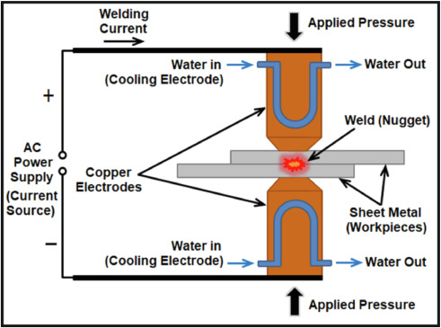
Figure 1.1: Resistance Spot Welding

  - Resistance Spot Welding Cycle
The Resistance Spot Welding (RSW) process consists of four distinct stages: Squeeze Time, Weld Time, Hold Time, and Off Time. These stages together form a complete welding cycle and play a crucial role in determining weld quality and nugget formation.

Squeeze Time
Squeeze time is the period during which the electrodes apply pressure to the workpieces before the welding current is initiated. During this stage, the metal sheets are firmly clamped together to ensure proper electrical contact and minimize contact resistance at undesired locations. Adequate squeeze time is essential for achieving consistent weld quality and preventing expulsion of molten metal.

Weld Time
Weld time is the duration for which electric current passes through the workpieces while electrode pressure is maintained. The electrical resistance at the interface of the sheets generates heat according to Joule's law, causing localized melting and the formation of a weld nugget. Weld time directly influences nugget size, weld strength, and overall joint quality.

Hold Time
Hold time begins immediately after the welding current is switched off while electrode force continues to be applied. During this stage, the molten weld nugget solidifies and cools under pressure. Maintaining sufficient hold time prevents shrinkage defects, improves joint integrity, and ensures proper solidification of the weld.

Off Time
Off time is the interval between the completion of one welding cycle and the beginning of the next. During this period, the electrodes are released, and the welded assembly may be repositioned for the subsequent weld. Off time also allows the electrodes to dissipate heat and return to suitable operating conditions.
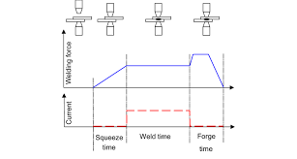
Figure 1.2: Schematic representation of the Resistance Spot Welding cycle showing squeeze time, weld time, hold time, and off time.

  - Resistance Spot Welding in Automotive Industry
Today, the top priority for the automobile sector is to reduce CO2 emissions because of the current environmental issues. Also, the vehicle weight reduction efforts are being made by companies to cut down on the fuel usage and most importantly the pollution. A standard car body frequently contributes nearly 30% of the total weight of a car and a car’s fuel economy increases by 5.5% when its weight is reduced by around 10%. In a modern automobile, there are typically 2000–5000 spot welds. A vehicle’s mechanical characteristics, structural performance, durability, safety design, stiffness, strength and integrity all are influenced by the resistance spot welds as well as the mechanical properties of the sheets.
In the automotive industry, Resistance Spot Welding is extensively employed in the assembly of the Body-in-White (BIW) structure, where numerous sheet metal components are joined to form the vehicle's primary load-bearing body before painting and final assembly operations.
Table1.1: Number of spotwelds used to assemble the Body in White (B.I.W.) of several brands and models, as presented at conferences. If data is available for updated models (e.g. Ford Fiesta), the data of the latest model are presented here.

Model | Number of spotwelds | [Reference]
Audi A4 Avant | 5061 | [Rebele et al., 2008]
Audi A6 | 5102 | [Wilde et al., 2004]
Audi Q5 | 5580 | [Rebele et al., 2008]
Citroën C4 | 4360 | [Perrot et al., 2004]
Citroën C5 Berline | 4051 | [Le Floch & Barbier, 2008]
Citroën C5 Tourer | 4282 | [Le Floch & Barbier, 2008]
Ford Fiesta 3-Door | 3184 | [Liesenfelder et al., 2008]
Ford Fiesta 5-Door | 3305 | [Liesenfelder et al., 2008]
Honda Jazz | 2060 | [Ito et al., 2008]
Jaguar XJ Saloon | 3185 | [White, 2006]
Jaguar XK Convertible | 2820 | [White, 2006]
Jaguar XK Coupe | 2820 | [White, 2006]
Mercedes SLK | 4840 | [Trost et al., 2004]
Mini Cabrio | 4178 | [Brunies et al., 2004]
Mini Hatch | 4475 | [Brunies et al., 2004]
Nissan Murano | 4307 | [Saito & Nakamura, 2004]
Nissan Teana | 5821 | [Michiura et al., 2008]
Opel Insignia | 6331 | [Heim et al., 2008]
Opel Vectra | 4613 | [Heim et al., 2008]
Peugeot 307 | 4434 | [Perrot et al., 2004]
Peugeot 307 Space Wagon | 4764 | [Perrot et al., 2002]
Peugeot 407 Sedan | 4335 | [Bonte & Deren, 2004]
Peugeot 407 Station Wagon | 4607 | [Bonte & Deren, 2004]
Renault Clio | 2916 | [Delhommeau & Hoareau, 2004]
Renault Laguna Coupe | 4379 | [Plaideau et al., 2008]
Renault Laguna Hatchback | 3998 | [Plaideau et al., 2008]
Renault Modus | 3746 | [Delhommeau & Hoareau, 2004]
Renault Twingo | 2213 | [Delhommeau & Hoareau, 2004]
Skoda Octavia 24 | 4333 | [Sekyr, 2004]
Skoda Octavia 34 | 4771 | [Sekyr, 2004]
Skoda Octavia 35 | 5011 | [Sekyr, 2004]
Skoda Superb 451 | 5051 | [Simon & Senkyr, 2008]
Skoda Superb 461 | 5157 | [Simon & Senkyr, 2008]
Volvo V50 | 3779 | [Jonsell et al., 2004]
Volvo XC60 | 4337 | [Lassi, 2008]

  - Dissimilar Resistance Spot Welding
Dissimilar resistance spot welding (DRSW) joins two different metals (e.g., aluminum to steel, or copper to aluminum) using heat generated by electrical resistance and applied pressure. It is widely used in automotive manufacturing to reduce vehicle weight, but it is highly challenging due to differing melting points, electrical/thermal conductivities, and the formation of brittle intermetallic compounds (IMCs).

    - Key Challenges

- Asymmetrical Heat Generation: Metals with high electrical resistivity heat up much faster than highly conductive metals. This causes unbalanced melting and asymmetrical weld nuggets.
- Intermetallic Compounds (IMC): When joining metals like Aluminium and Steel or Aluminium and Magnesium, high heat triggers chemical reactions that create brittle IMCs, drastically weakening the joint.]
- Melting Point Discrepancies: Joining materials with vastly different melting points (e.g., Copper and Aluminium) can result in the lower-melting-point metal evaporating or melting excessively before the other metal forms a bond.

    - Solutions

- Electrode Adjustments: Using different electrode materials or utilizing domed electrodes with varying contact radii on the upper and lower sheets helps balance the heat input.
- Process Interlayers: Applying a thin, compatible metal coating (e.g., Nickel, Zinc, or Copper via cold spraying) between the two sheets prevents brittle IMCs and promotes diffusion.
- Optimized Parameters: Applying precise welding schedules—such as a stepped current profile, weld pulsation, or post-weld tempering—controls the heating and cooling rates to minimize thermal stress.
- Hybrid Methods: Utilizing external energy sources like ultrasonic vibration or laser assistance alongside traditional resistance welding aids in grain refinement and breaks up IMCs for a stronger bond.

  - VARIOUS RESEARCH APPROACHES TO ENHANCE THE PERFORMANCE OF DISSIMILAR METAL WELDS

Study of IMC:
Layer In dissimilar resistance spot welding, an intermetallic compound layer refers to a thin layer of a compound that forms at the interface between two dissimilar metal sheets or parts that are being joined together through the process of resistance spot welding. The specific intermetallic compounds that form during dissimilar resistance spot welding depend on the composition of the metals being joined and the welding conditions, such as temperature, pressure and welding time.

Interlayers Used:
Interlayers are thin materials placed between two dissimilar metals during welding to improve joint quality, reduce brittle intermetallic compounds (IMCs), and increase strength. The review discusses several interlayers:

Interlayer | Metal Combination | Main Findings
Nickel (Ni) foil (0.2 mm) | AA5754 Al – AZ31B Mg | Prevented brittle Al–Mg IMCs, improved weld quality and mechanical properties. Excessive welding current caused cracks and porosity.
Sn-coated steel interlayer | AA5052 Al – AZ31 Mg | Suppressed Al–Mg IMC formation and increased tensile shear strength by about 88%. Failure shifted away from the interface, indicating stronger joints.
Thin aluminum insert (Ultrasonic + RSW) | A6061-T6 Al – 1008 Steel | Aluminum insert acted as an intermediate layer, enabling successful joining and achieving about 61% joint efficiency.
Zinc layer / Galvanized coating | Al5052 – Steel | Zinc influenced IMC formation and nugget size. Excessively thick IMC layers reduced strength due to brittleness.
Zinc powder | Aluminum – Mild Steel | Improved hardness and mechanical performance. Best results obtained at 9000 A current and 0.5 s welding time.
Copper and Zinc fillers | AA6061 Al – Carbon Steel | Both improved joint strength; copper filler performed better than zinc. Welding current had a stronger effect than welding time.
Ni–Cu alloy interlayer | TC4 Titanium – Q235 Steel | Produced reaction and diffusion layers that improved bonding between titanium and steel.
Aluminum interlayer | SS316L Stainless Steel – Ti6Al4V Titanium | Reduced void formation and improved weld strength. Longer holding times further increased strength.
Ni + Al₂O₃ coating | AA5754 Al – DC01 Steel | Showed the best tensile shear strength among coating interlayers. Cold-spray technology produced mechanically strong joints.
Al–Mg interlayer | A6061-T6 Al – 304 Stainless Steel | Produced a uniform ~2 μm IMC layer, increasing tensile shear and fatigue strength compared to joints without an interlayer.
Zn-coated steel interlayer | Aluminum – Magnesium | Performed much better than Zn foil. Prevented direct Al–Mg mixing and achieved about 74% of the strength of similar Mg-Mg welds.
Zn slice interlayer (50 μm) | DP600 Steel – A5052 Al | Increased tensile-shear load by 28%, improved ductility, and promoted plug failure instead of interfacial failure.

Chapter 2
Material Selection
2.1 Introduction
Material selection plays a crucial role in the design and manufacturing of automotive structures, as it directly influences vehicle performance, safety, fuel efficiency, and production cost. In recent years, the automotive industry has increasingly adopted advanced high-strength steels (AHSS) to reduce vehicle weight while maintaining high crashworthiness and structural integrity. As a result, joining dissimilar grades of steel has become a common requirement in modern vehicle manufacturing.

In the present study, Dual Phase 1180 (DP1180) steel and Interstitial Free (IF) steel were selected for resistance spot welding investigations. These materials represent two different categories of automotive steels with significantly different mechanical and metallurgical properties.

DP1180 is an advanced high-strength steel characterized by a ferrite-martensite microstructure, providing high tensile strength and excellent energy absorption capability. Due to its superior strength-to-weight ratio, DP1180 is widely used in critical structural and safety components of automobiles.

On the other hand, IF steel is a low-carbon steel with a predominantly ferritic microstructure. It possesses excellent formability, ductility, and surface quality, making it suitable for outer body panels and components requiring complex shaping operations.

The combination of DP1180 and IF steel in a single structure enables manufacturers to achieve an optimum balance between strength, weight reduction, formability, and cost. However, the significant differences in their mechanical, thermal, and electrical properties make the welding process more challenging. Therefore, studying the resistance spot welding behavior of these dissimilar materials is important for understanding weld quality, nugget formation, and joint performance.
The chemical composition and mechanical properties of the selected materials are presented in the following sections.
2.2 Advanced High Strength Steel
The emission of CO2, NOx and particulates from commercial vehicles is a major issue with respect to global warming. Light vehicles have been estimated to account for 20% of the total CO2 delivered into the atmosphere in Europe, the USA and other developed global areas. The growth of the number of vehicles worldwide continues to increase and associated with this is increased damage to the environment, as the internal combustion engine still remains by far the most common power source for vehicles. To tackle these issues, the automotive industry is striving for the reduction of car body weight to increase the fuel efficiency and reduce CO2 emission without compromising the safety and crashworthiness of vehicles. Development of a new generation of steels named as ‘advanced high strength steels’ (AHSS) is a successful attempt to help the engineers to meet requirements for safety, CO2 emission and durability at lower costs. This new generation of materials provides higher strength, while maintaining the high formability required for the complex aesthetic designs of new vehicles. The earliest grades of AHSS were unveiled and applied to the car body in 1998 when a consortium of 35 sheet steel producers working on the Ultra-Light Steel Auto Body (ULSAB) program introduced their designed lightweight steel auto body structure that would fulfil the requirements for safety and fuel efficiency. AHSS were further developed in strength and ductility through pursuant programs such as Future Steel Vehicle (FSV) started by World Auto Steel in 2008. The FSV program enabled the steel makers to enhance the strength of AHSS to the GPa range and paved the way for a 39% reduction in car body weight. Over the years, owing to simultaneous development of new processes and equipment to produce and form materials, new types and grades of AHSS have been introduced.

It has been well documented that AHSS are the fastest growing materials for the future automotive applications as shown in Figure 1.2. It arises from the fact that the automotive industry strategy to reduce greenhouse gas emissions has been founded on vehicle weight reduction. While the superior strength of the material is of crucial importance to guarantee the safety of the vehicle in the crash event, AHSSs are Introduction 5 qualified to meet this requirement with thinner materials. Besides, lightweight car bodies can be constructed with little or no additional cost compared to conventional car body structures encouraging steel makers to extend their effort to push the limit of properties proposed by AHSS.
2.3 Selection of DP1180 Steel
DP1180 belongs to the family of Advanced High Strength Steels (AHSS). It consists of a ferritic matrix containing a significant amount of martensite, which provides an excellent combination of strength and ductility. The high martensite content is responsible for its superior tensile strength, making it suitable for structural components that are required to absorb impact energy during vehicle collisions.

The increasing use of DP1180 steel in the automotive sector is primarily driven by the need to reduce vehicle weight without compromising passenger safety. Components manufactured from DP1180 can achieve the same structural performance with reduced thickness compared to conventional steels, resulting in significant weight savings.

Typical applications of DP1180 steel include:
- B-pillars
- Side impact beams
- Reinforcement members
- Roof rails
- Crash management systems
- Structural body components
Due to its high strength and relatively complex microstructure, DP1180 presents unique challenges during welding, making it an important material for resistance spot welding research.

Microstructure:
DP590 consists of a soft, ductile ferrite matrix with isolated islands of hard martensite. During RSW, rapid heating and cooling cause the weld nugget and Heat-Affected Zone (HAZ) to transform into hard, brittle martensite, which can lead to interfacial failure under stress.
During Resistance Spot Welding (RSW) of DP590, the rapid thermal cycle creates three distinct microstructural zones, significantly altering the base metal's original ferrite-martensite structure. Proper parameter control is critical to manage brittle phases and ensure joint strength.
The 3 Core Microstructural Zones:
Fusion Zone (Weld Nugget):
- Reaches peak temperatures above the melting point, followed by rapid cooling.
- Base metal melts and solidifies into a brittle, hard lath martensite structure.
- Prone to low fracture toughness due to the high cooling rate.
Heat-Affected Zone (HAZ):
Subject to steep temperature gradients, divided into sub-zones -
- Subcritical HAZ: Heated below the Ac₁ critical temperature, causing martensite to over-temper (softening).
- Intercritical HAZ: Heated between Ac₁ and Ac₃, transforming partially into austenite which cools back into a mixture of fine and coarse martensite mixed with ferrite.
- Supercritical HAZ: Heated above Ac₃, leading to complete austenitization and rapid cooling into coarse martensite.

Base Metal:
- Unaffected by the welding heat.
- Retains the original dual-phase microstructure: islands of hard martensite dispersed in a ductile, continuous ferrite matrix.
2.4 Selection of IF Steel
Interstitial Free (IF) steel is a low-carbon steel specifically designed to provide excellent formability and surface quality. The carbon and nitrogen content in IF steel are reduced to extremely low levels through stabilization using titanium and niobium, resulting in a predominantly ferritic microstructure.
The absence of interstitial elements improves ductility and deep drawability, making IF steel particularly suitable for components requiring extensive forming operations. In addition, IF steel offers good surface finish and dimensional accuracy, which are essential for visible automotive body panels.
Typical applications of IF steel include:
- Door panels
- Roof panels
- Hood panels
- Trunk lids
- Side body panels
- Inner automotive body structures
Although IF steel has lower strength compared to AHSS grades, its excellent formability and low manufacturing cost make it an indispensable material in automobile production.
Microstructure of IF Steel
Interstitial Free steel is produced with extremely low concentrations of carbon and nitrogen, typically below 0.01 wt%. Titanium and niobium are added during steelmaking to react with these interstitial elements and form stable carbides and nitrides. As a result, the ferrite matrix remains largely free from interstitial atoms, reducing strain aging and improving ductility. The ferritic microstructure obtained through this process provides excellent deep drawability and surface quality, which are essential for manufacturing automotive body panels.
2.5 Justification for the Selection of Materials (DP1180 and IF Steel)
The selection of DP1180 and IF steel for the present study was motivated by their widespread use in modern automotive body structures. Vehicle manufacturers often combine high-strength steels and highly formable steels within a single assembly to achieve an optimum balance between safety, weight reduction, manufacturability, and cost.
DP1180 provides high strength and crash resistance, while IF steel contributes superior formability and ease of manufacturing. Consequently, joining these two materials through resistance spot welding is a common industrial requirement.
However, the significant differences in their mechanical properties, electrical resistivity, thermal conductivity, and microstructures can influence heat generation, nugget formation, weld strength, and microstructural evolution during welding. These differences make the welding process more complex compared to welding similar materials.
Therefore, investigating the resistance spot welding behavior of DP1180 and IF steel is important for understanding the effect of welding parameters on weld quality and for developing reliable welding schedules for industrial applications.
2.6 Conclusion
DP1180 and IF steel were selected for this study because they represent two important classes of automotive steels with contrasting properties. DP1180 offers high strength and enhanced crash performance, whereas IF steel provides excellent formability and surface quality. The resistance spot welding of these dissimilar materials is of significant industrial relevance, making them suitable candidates for investigating weld quality, nugget formation, mechanical performance, and microstructural characteristics.
Chapter 3
Parameter Selection for Weld Condition
3.1 Introduction
The quality of a resistance spot weld is strongly influenced by the selection of welding parameters such as welding current, weld time, electrode force, hold time, and squeeze time. In dissimilar welding of DP1180 advanced high-strength steel and IF steel, parameter optimization becomes particularly important due to the significant differences in electrical resistivity, thermal conductivity, and mechanical properties of the two materials. Appropriate parameter selection is necessary to ensure adequate nugget formation while preventing defects such as expulsion, excessive indentation, and electrode sticking.
3.2 Material Considerations
DP1180 is a third-generation Advanced High Strength Steel (AHSS) characterized by high tensile strength and a martensitic microstructure. In contrast, IF steel possesses a ferritic microstructure with lower strength and higher ductility.
The differences in material characteristics influence heat generation during welding. DP1180 generally exhibits higher electrical resistance, resulting in greater heat generation at the faying interface. Therefore, welding parameters must be selected carefully to achieve a balanced heat input and a sound weld nugget.
3.3 Selection of Welding Current
Welding current is the most influential parameter in resistance spot welding, as heat generation follows Joule's law:
Q²RT
where:
Q = Heat generated (J)
I = Welding current (A)
R = Electrical resistance (Ω)
t = Welding time (s)
For DP1180–IF steel welds, a current range of 6–10 kA is commonly selected. Lower currents may result in insufficient nugget formation, whereas excessively high currents can cause expulsion and severe electrode indentation. Based on preliminary trials, welding currents are selected to produce nuggets satisfying the minimum nugget diameter criterion.
3.4 Selection of Weld Time
Weld time determines the duration for which current flows through the sheets. Increasing weld time increases total heat input and promotes nugget growth.
For the present investigation, weld times in the range of 200–500 ms (or approximately 10–25 cycles at 50 Hz) are considered. Short weld times may lead to incomplete fusion, while excessive weld times can promote grain coarsening and electrode wear.
3.5 Selection of Electrode Force
Electrode force affects contact resistance and current distribution during welding. A higher force reduces contact resistance and suppresses expulsion, whereas insufficient force may lead to unstable nugget formation.
For DP1180–IF steel joints, an electrode force ranging from 2.5–5.0 kN is generally employed. The selected force should ensure adequate contact between the sheets while minimizing surface indentation.
3.6 Selection of Squeeze Time
Squeeze time is the interval between electrode closure and current initiation. This period allows the electrodes to attain the desired force and ensures proper sheet contact before welding.
A squeeze time of 400+400ms is typically adopted to establish stable electrical contact and improve weld consistency.

3.7 Selection of Hold Time
Hold time refers to the period during which electrode force is maintained after the welding current is switched off. It facilitates solidification of the molten nugget under pressure.
A hold time of 10–20 cycles is generally selected to reduce shrinkage defects and improve weld strength.
3.8 Electrode Selection
Copper-based electrodes, particularly Class 2 Cu–Cr–Zr electrodes, are widely used for welding AHSS grades. These electrodes provide high electrical conductivity, adequate strength at elevated temperatures, and good resistance to electrode wear.
For the present study, dome-shaped electrodes with a tip diameter of approximately 6 mm are employed.
3.9 Final Welding Schedule
Based on literature recommendations and preliminary trials, the welding schedule adopted for DP1180–IF steel dissimilar joints is summarized below:
Parameter | Selected Range
Welding Current | 6–10 kA
Weld Time | 200–500 ms
Electrode Force | 2.5–5.0 kN
Squeeze Time | 15–25 cycles
Hold Time | 10–20 cycles
Electrode Material | Cu–Cr–Zr
Electrode Tip Diameter | 6 mm
3.10 Summary
The welding parameters were selected considering the differences in mechanical and thermal properties of DP1180 and IF steel. The chosen parameter ranges provide sufficient heat generation for nugget formation while minimizing welding defects such as expulsion, excessive indentation, and electrode degradation. These parameters serve as the basis for subsequent experimentation and optimization of dissimilar DP1180–IF steel resistance spot welds.
Chapter 4
Welding Experiment
4.1 Objective of the Experiment
The objective of the present study was to determine the optimum welding current for resistance spot welding (RSW) of dissimilar DP1180 and IF steel sheets. The experiment was conducted to identify the current at which expulsion occurs and to evaluate the weld quality through tensile testing and nugget diameter measurements.
4.2 Experimental Procedure
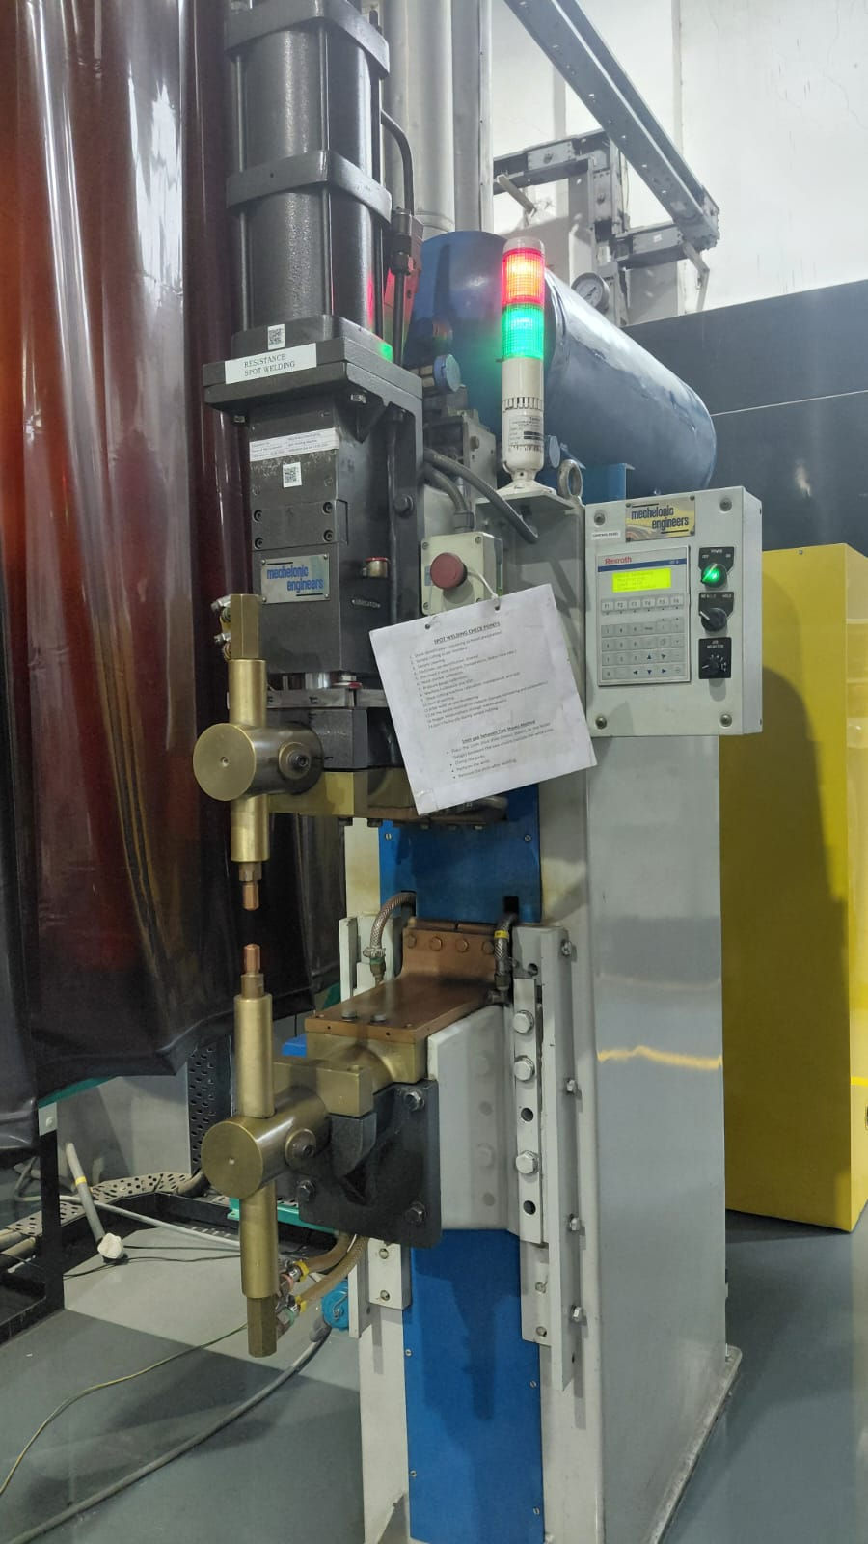
Resistance spot welding experiments were carried out on DP1180 steel sheets of thickness 1.2 mm and IF steel sheets of thickness 0.8 mm. The welding parameters such as weld time, electrode force, squeeze time, hold time, and electrode geometry were maintained constant throughout the study. The welding current was selected as the variable parameter.
Figure 4.1: Resistance Spot Welding Machine
Initially, welding trials were performed by varying the welding current from 5 kA to 8 kA. For these preliminary trials, DP1180 was placed on the top side and IF steel on the bottom side. The purpose of these experiments was to determine the current range capable of producing sound welds and to identify the onset of expulsion.
After welding, each sample was visually inspected for weld quality and signs of expulsion. The weld nugget diameter was also evaluated after mechanical testing.

4.3 Determination of Expulsion Current
As the welding current increased, the heat generated at the faying interface also increased, resulting in larger weld nuggets. Stable welds were obtained at lower and intermediate current levels. However, when the welding current reached 7.5 kA, expulsion of molten metal from the weld zone was observed.

The occurrence of expulsion indicated excessive heat input, leading to instability in the welding process and possible deterioration of weld quality. Therefore, 7.5 kA was identified as the expulsion current for the DP1180–IF steel combination under the selected welding conditions
4.4 Selection of Optimum Welding Current
To ensure adequate nugget formation without the occurrence of expulsion, a welding current below the expulsion limit was selected.
Based on the experimental observations, 6.5 kA was chosen as the optimum welding current. This current provided stable weld formation and produced sound weld nuggets without any visible expulsion.
The selected current was subsequently used for further welding experiments and mechanical characterization.
4.5 Preparation of Weld Samples
Using the selected welding current of 6.5 kA, weld samples were prepared in two different sheet arrangements:
1. DP1180 (Top) + IF Steel (Bottom)
2. IF Steel (Top) + DP1180 (Bottom)
For each configuration, three samples were produced under identical welding conditions to ensure repeatability and reliability of the experimental results.

4.6 Tensile Testing of Welded Samples
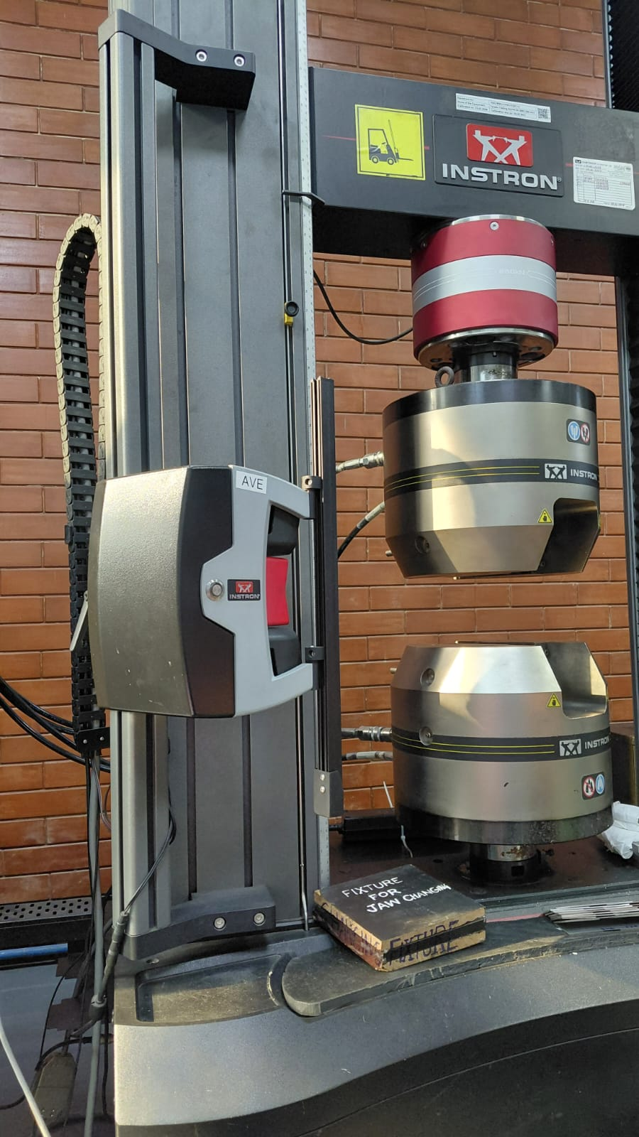
The mechanical performance of the welded joints was evaluated using a Tensile Testing Machine. Each welded specimen was subjected to tensile loading until failure occurred.
The maximum load sustained by the weld before failure was recorded for all samples. The tensile test results provided information regarding the strength of the spot weld and helped in assessing the effectiveness of the selected welding parameters.
The mode of failure observed during testing was also noted for comparison of weld quality among the different sheet configurations
Figure 4.2: Tensile Testing Machine

4.7 Measurement of Nugget Diameter
Following tensile testing, the failed weld specimens were separated and examined to determine the weld nugget diameter.
The nugget diameter was measured using a Vernier caliper. Measurements were taken on both sheet sides after failure, and the average values were recorded. The nugget diameter serves as an important indicator of weld quality, as larger and well-formed nuggets generally correspond to stronger weld joints.
4.8 Discussion of Results
The experimental investigation revealed that the welding current significantly influenced weld quality and nugget formation. As the current increased, the nugget diameter increased due to higher heat generation at the weld interface.
Expulsion was first observed at 7.5 kA, indicating that the heat input exceeded the acceptable limit for the given material combination and welding conditions. Therefore, 6.5 kA was selected as the optimum welding current.
The tensile test results confirmed that sound weld joints were produced at this current level. Furthermore, the nugget diameter measurements indicated consistent weld formation in both sheet arrangements.
Differences in nugget diameter between the DP1180 and IF steel sides can be attributed to the variation in thermal and electrical properties of the two materials, which affect heat distribution and nugget growth during welding.

Table 4.1: Data obtained during the experiment

Current Range
S NO. | Current (kA) |  |  | Force (kN) |  |  | Nugget Dia (mm) | DCR | Failure
BY1 | 5 |  |  | 3.19 |  |  | 4.11 | DAT-00 | PF
BY2 | 5.5 |  |  | 3.59 |  |  | 4.16 | DAT-01 | PF
BY3 | 6 |  |  | 3.62 |  |  | 4.89 | DAT-02 | PF
BY4 | 6.5 |  |  | 3.76 |  |  | 5.1 | DAT-03 | PF
BY5 | 7 |  |  | 3.88 |  |  | 5.22 | DAT-04 | PF
BY6 | 7.5 |  |  | 3.85 |  |  | 4.81 | DAT-05 | PF(Exp)
BY7 | 8 |  |  | 3.95 |  |  | 4.5 | DAT-06 | PF(Exp)
DP1180(1.2mm-TOP) + IF(0.8mm-BOTTOM)
BY8 | 6.5 |  |  | 4.14 |  |  | 5.34 | DAT-07 | PF
BY9 | 6.5 |  |  | 3.97 |  |  | 5.19 | DAT-08 | PF
BY10 | 6.5 |  |  | 3.98 |  |  | 5.02 | DAT-09 | PF
IF(0.8mm-TOP) + DP1180(1.2mm-BOTTOM)
BY11 | 6.5 |  |  | 3.78 |  |  | 5.34 | DAT-10 | PF
BY12 | 6.5 |  |  | 3.78 |  |  | 5.19 | DAT-11 | PF
BY13 | 6.5 |  |  | 3.8 |  |  | 5.24 | DAT-12 | PF
AVERAGE NUGGET DIAMETER (mm)= | 4.931538462
STD DEVIATION IN CURRENT (kA)= | 0.763762616
STD DEVIATION IN NUGGET DIA (mm)= | 0.423750047

4.9 Summary
A series of resistance spot welding experiments were conducted on dissimilar DP1180 and IF steel sheets to determine the optimum welding current. Welding trials performed between 5 kA and 8 kA showed that expulsion occurred at 7.5 kA. Consequently, a welding current of 6.5 kA was selected for further experimentation.
Three welded samples were prepared for each sheet arrangement and tested using a Tensile Testing Machine. Following tensile testing, the weld nugget diameters were measured using a Vernier caliper. The results demonstrated stable weld formation and satisfactory weld quality at the selected current, making 6.5 kA suitable for subsequent metallurgical and mechanical analysis.

Chapter 5
Metallographic Sample Preparation
5.1 Introduction
After the completion of resistance spot welding and mechanical testing, metallographic sample preparation was carried out to examine the weld nugget and microstructural characteristics of the dissimilar DP1180–IF steel joints. Proper sample preparation is essential for obtaining a clear view of the weld zone, heat-affected zone (HAZ), and base metal regions under microscopic examination.
For the metallographic study, samples BY12 and BY17 were selected. Sample BY12 consisted of DP1180 positioned at the top and IF steel at the bottom, whereas sample BY17 consisted of IF steel positioned at the top and DP1180 at the bottom.

5.2 Sectioning of Welded Samples
The first step in metallographic sample preparation was sectioning of the welded specimens. The selected samples were cut through the center of the weld nugget using a cutting machine. Care was taken to ensure that the cut passed through the middle of the weld so that the complete weld cross-section could be observed during microscopic examination.
The sectioned samples contained the weld nugget, heat-affected zone, and base metal regions of both DP1180 and IF steel sheets.
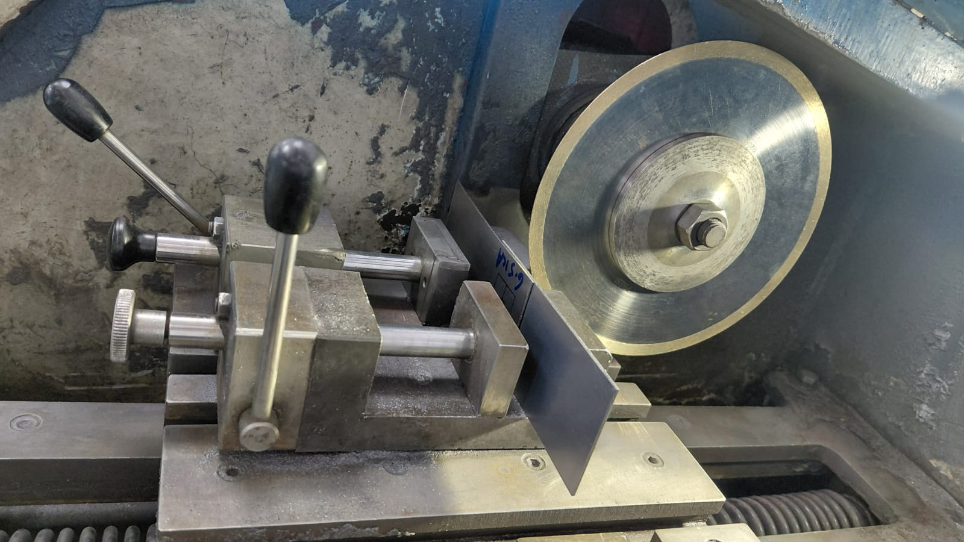
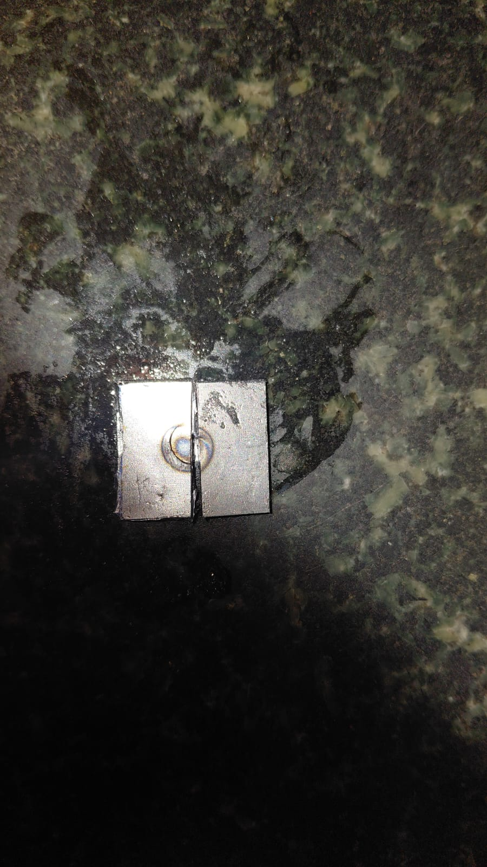
5.3 Mounting of Samples
After sectioning, the samples were mounted to facilitate easier handling during grinding, polishing, and microscopic examination.
Hot mounting was performed using Bakelite as the mounting material. The sectioned specimens were placed in the mounting press and subjected to heat and pressure, resulting in a rigid mounted sample with the weld cross-section exposed for further preparation.
The mounted specimens provided adequate edge support and protected the sample during subsequent polishing operations.
5.4 Polishing of Samples
Following mounting, the specimens were polished to obtain a smooth and scratch-free surface suitable for microstructural examination.
The polishing process was carried out in multiple stages using progressively finer abrasive papers. This step removed the surface irregularities and scratches produced during the cutting and mounting processes. Final polishing was performed to produce a mirror-like finish on the specimen surface.
Proper polishing is essential to clearly reveal the weld nugget and microstructural features during microscopic analysis.
5.5 Etching of Samples
After polishing, the specimens were etched using a suitable metallographic etchant. The purpose of etching was to reveal the microstructural features of the weld region, heat-affected zone, and base metal.
The etching process selectively attacked different microstructural constituents, making the grain boundaries and phase transformations visible under microscopic observation. This enabled clear differentiation between the weld nugget, heat-affected zone, and parent materials.
5.6 Prepared Samples for Microstructural Analysis
The metallographic preparation was performed on the following samples:
BY12| DP1180 (Top) + IF Steel (Bottom)
BY17| IF Steel (Top) + DP1180 (Bottom)

These prepared specimens were subsequently used for microstructural examination and analysis of the weld nugget characteristics
5.7 Summary
Metallographic sample preparation was carried out on selected resistance spot welded specimens to facilitate microstructural characterization. Samples BY12 and BY17 were sectioned through the weld nugget using a cutting machine, mounted using Bakelite through the hot mounting process, polished to obtain a mirror-finished surface, and finally etched to reveal the weld microstructure. The prepared samples were then ready for microscopic examination of the weld nugget, heat-affected zone, and base metal regions.

Chapter 6
Image Analysis Using Stereomicroscope
6.1 Introduction
After metallographic sample preparation and etching, the welded specimens were examined using a stereomicroscope equipped with image analysis software. The objective of this analysis was to evaluate the weld geometry and identify the various metallurgical regions formed during resistance spot welding, namely the Fusion Zone (FZ), Heat Affected Zone (HAZ), and Base Metal (BM).
The stereomicroscope images also enabled measurement of nugget diameter and penetration depth, which are important indicators of weld quality and joint integrity.
Two representative samples, BY12 and BY17, were selected for detailed examination.
6.2 Identification of Weld Regions
The stereomicroscope images revealed three distinct regions within the welded joint:
Fusion Zone (FZ)
The central region of the weld represents the Fusion Zone or weld nugget. This region experienced temperatures above the melting point during welding, resulting in complete melting and subsequent solidification. The fusion zone forms the actual metallurgical bond between the two sheets and largely determines the strength of the weld joint.
Heat Affected Zone (HAZ)
Surrounding the fusion zone is the Heat Affected Zone. Although this region did not melt during welding, it was exposed to elevated temperatures that altered its microstructure and mechanical properties. The extent of the HAZ provides information about the heat input during welding.
Base Metal (BM)
The outermost regions remained unaffected by the welding thermal cycle and retained their original microstructure and properties. These regions are referred to as the base metal.
The transition from the fusion zone to the HAZ and subsequently to the base metal was clearly visible in the etched cross-sectional images.
6.3 Analysis of Sample BY12 (DP1180 Top + IF Bottom)
For sample BY12, DP1180 was positioned on the top side while IF steel was placed on the bottom side.
The stereomicroscope image revealed a well-formed fusion zone with a nugget diameter of approximately 4.55 mm. The fusion zone exhibited a relatively symmetrical shape around the weld centerline, indicating successful melting and solidification during welding.
The penetration depth on the DP1180 side was measured as 0.874 mm, whereas the penetration depth on the IF steel side was 0.424 mm.
A distinct heat affected zone was observed around the weld nugget. The HAZ appeared wider on the DP1180 side, suggesting greater heat retention and thermal influence within the thicker sheet. The transition from the fusion zone to the HAZ and finally to the base metal could be clearly distinguished after etching.
The significantly higher penetration depth on the DP1180 side indicates that the weld nugget developed preferentially toward the DP1180 sheet.
6.4 Analysis of Sample BY17 (IF Top + DP1180 Bottom)
For sample BY17, the sheet arrangement was reversed, with IF steel positioned on the top side and DP1180 placed on the bottom side.
The measured nugget diameter was approximately 4.774 mm, slightly larger than that observed in sample BY12.
The penetration depth was found to be 0.437 mm in IF steel and 0.926 mm in DP1180.
The fusion zone appeared slightly larger compared to BY12, indicating a marginal increase in weld nugget growth. Similar to BY12, the HAZ surrounding the fusion zone was clearly visible. The HAZ extended further into the DP1180 side than into the IF steel side, indicating that the thermal cycle affected the DP1180 sheet more significantly.
Despite the reversal of sheet position, the weld nugget continued to penetrate deeper into DP1180 than into IF steel.
6.5 Discussion of Results
The stereomicroscope analysis revealed an important trend: the weld nugget geometry was influenced more by material properties than by sheet position.
Although the sheet arrangement was reversed between BY12 and BY17, the penetration depth remained consistently higher in DP1180.
Several factors may explain this behavior:
Influence of Sheet Thickness
DP1180 had a thickness of 1.2 mm while IF steel had a thickness of 0.8 mm. The thicker sheet can absorb and sustain a greater amount of heat before complete melting occurs. Consequently, the fusion zone tends to extend further into DP1180, resulting in greater penetration depth.
Influence of Thermal Characteristics
The two steels possess different thermal properties. During welding, heat generated at the faying interface is distributed unevenly between the sheets. The thermal behavior of DP1180 promotes greater heat retention, resulting in increased nugget growth and deeper penetration.
Influence of Electrical Resistance
Resistance spot welding relies on electrical resistance for heat generation. Variations in electrical resistance between DP1180 and IF steel affect local heat generation and influence nugget growth. This contributes to the asymmetrical nature of the weld nugget.
Effect of Sheet Arrangement
The slight increase in nugget diameter from 4.55 mm to 4.774 mm when IF steel was placed on the top side suggests that electrode cooling conditions and current distribution were affected by the sheet arrangement. However, the effect was relatively small compared to the influence of material properties.
Fusion Zone and HAZ Development
The presence of a clearly defined fusion zone and heat affected zone confirms that sufficient heat input was achieved at the selected welding current of 6.5 kA. The larger penetration depth observed in DP1180 indicates that the fusion zone developed preferentially toward the stronger and thicker sheet.
The observed weld geometry demonstrates that successful metallurgical bonding was achieved in both sheet configurations.

Chapter 7
Conclusions
The present study investigated the resistance spot welding behavior of dissimilar DP1180 Advanced High Strength Steel (AHSS) and Interstitial Free (IF) steel using an MFDC resistance spot welding machine. The objective was to determine suitable welding parameters, evaluate weld quality through mechanical testing, and study the influence of sheet arrangement on weld nugget formation and penetration characteristics.
Based on the experimental observations and stereomicroscopic analysis, the following conclusions can be drawn:
1. Welding trials performed between 5 kA and 8 kA revealed that expulsion occurred at a welding current of 7.5 kA. Therefore, 6.5 kA was selected as the optimum welding current for producing defect-free welds.
2. Sound resistance spot welds were successfully produced for both sheet configurations, namely DP1180 (Top) – IF Steel (Bottom) and IF Steel (Top) – DP1180 (Bottom), demonstrating the feasibility of joining these dissimilar materials using optimized welding parameters.
3. Tensile testing confirmed the formation of mechanically stable weld joints, while nugget diameter measurements indicated consistent weld formation at the selected welding current.
4. Metallographic examination using a stereomicroscope revealed distinct Fusion Zone (FZ), Heat Affected Zone (HAZ), and Base Metal (BM) regions in both samples. The presence of a well-defined fusion zone confirmed successful metallurgical bonding between the two dissimilar steels.

5. Sample BY12 (DP1180 Top + IF Bottom) exhibited a nugget diameter of 4.55 mm with penetration depths of 0.874 mm in DP1180 and 0.424 mm in IF steel. Sample BY17 (IF Top + DP1180 Bottom) showed a slightly larger nugget diameter of 4.774 mm with penetration depths of 0.926 mm in DP1180 and 0.437 mm in IF steel.
6. In both configurations, the weld nugget penetrated significantly deeper into the DP1180 sheet than into the IF steel sheet. This observation indicates that weld nugget growth was asymmetric and preferentially developed toward the DP1180 side.
7. The asymmetric weld geometry can be attributed to the combined influence of sheet thickness difference, thermal properties, electrical resistance, and material chemistry. Since DP1180 possesses higher strength and a more complex alloy composition compared to the lean chemistry IF steel, the heat generation and distribution during welding were not uniform across the weld interface.
8. The slight increase in nugget diameter observed when IF steel was positioned on the top side suggests that sheet arrangement influences weld formation. In MFDC resistance spot welding, current flows in a fixed direction from the positive upper electrode to the negative lower electrode. Consequently, reversing the sheet arrangement alters current flow conditions, heat balance, and electrode cooling behavior, resulting in minor changes in weld geometry.
9. However, the experimental results indicate that material properties had a greater influence on nugget formation than sheet positioning alone. Despite reversing the sheet arrangement, the fusion zone consistently extended further into the DP1180 side, confirming the dominant role of material characteristics in determining weld geometry.
10. The study demonstrates that understanding the interaction between welding parameters, material properties, and sheet arrangement is essential for achieving consistent weld quality in dissimilar steel joints.

Automotive Relevance and Industrial Significance
The automotive industry is increasingly adopting multi-material body structures to achieve weight reduction while maintaining high levels of passenger safety. Advanced High Strength Steels such as DP1180 are commonly used in structural and crash-resistant components, whereas IF steel is widely used in body panels because of its excellent formability and surface finish.
The successful joining of these dissimilar materials is therefore a critical requirement in modern automobile manufacturing. The findings of this study provide valuable insight into the behavior of DP1180–IF steel welds and the influence of sheet arrangement on weld quality.
The observed relationship between material properties and nugget growth can assist automotive manufacturers in optimizing welding schedules for body-in-white (BIW) structures. Understanding how fusion zone geometry, penetration depth, and heat affected zones vary with material arrangement can help improve joint reliability, reduce weld defects, and enhance crash performance.
Furthermore, the results highlight the importance of considering not only welding current but also material chemistry, sheet thickness, and electrode polarity when designing welding procedures for dissimilar steel combinations. Such knowledge contributes to the development of lighter, stronger, and safer vehicles while maintaining manufacturing efficiency and product quality.
Overall, the present investigation demonstrates that resistance spot welding is an effective joining technique for DP1180 and IF steel combinations and provides a foundation for further studies on microstructural evolution, hardness distribution, and mechanical performance of dissimilar automotive steel joints.

